ASSIGNMENT 3

Name: Avishkaar Pawar

Semester : 4th

Course : B.Sc (H) Computer Science

Roll No : AD-1224

Date-of-Submission : 07 April 6, 2023

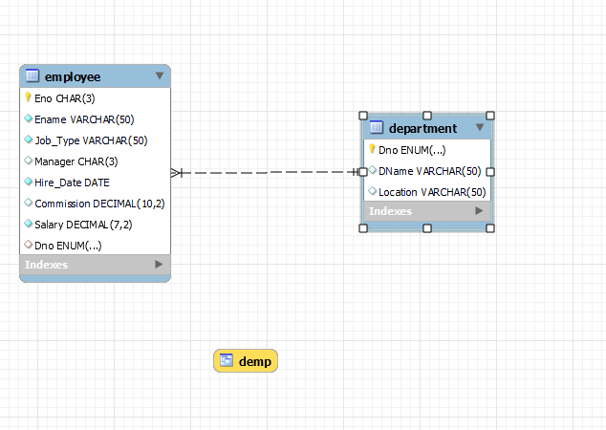

**/* DDL COMMANDS */**

create database EMP_DEPT;

use EMP_DEPT;

create table Department(

Dno enum('10','20','30','40','50') NOT NULL PRIMARY KEY,

DName varchar(50) DEFAULT NULL,

Location varchar(50) Default "New Delhi"

);

/*Foreign key references Employee(Eno)*/

create table Employee (

Eno char(3) NOT NULL primary key,

Ename Varchar(50) not null,

Job_Type varchar(50) not null,

Manager char(3) ,

Hire_Date date Not Null,

Commission Decimal(10,2),

Salary Decimal(7,2) Not Null,

Check (5000>Salary and Salary>1000),

Dno enum('10','20','30','40','50'),

foreign key (Dno) references Department(Dno)

);

**QUERIES**

/* Question 1

Query to display Employee Name, Job, Hire Date, Employee Number for each employee with the Employee Number appearing first */

**Select Eno, Ename,Job_Type,Hire_Date from employee;**

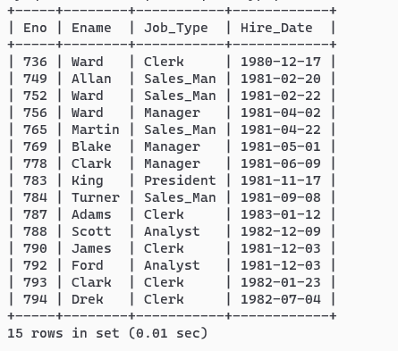

/* Question 2

Query to display Unique Jobs from the Employee Table. */

**select distinct job_type from employee;**

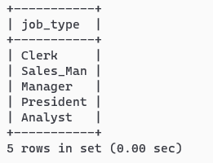

/* Question 3

Query to display the Employee Name concatenated by a Job separated by a comma.

*/

**select concat_ws(",",ename,job_type) from employee;**

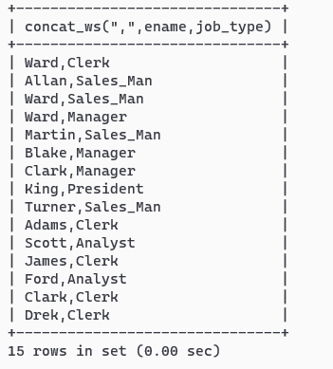

/* Question 4

Query to display all the data from the Employee Table. Separate each Column by a comma and name

the said column as THE_OUTPUT.

*/

**select concat_ws(" , ", eno, ename,job_type , manager, hire_date, commission,salary,dno) THE_OUTPUT from employee;**

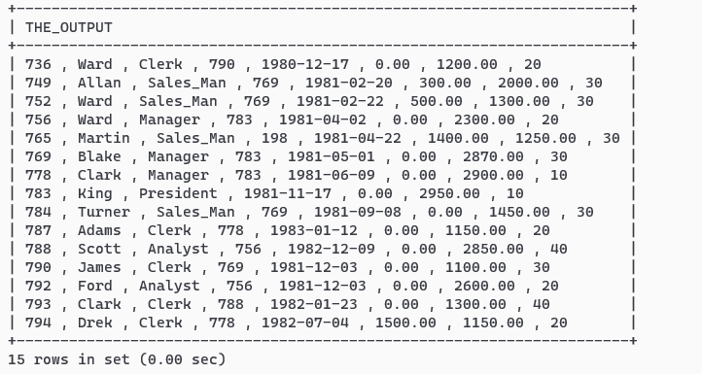

/* Question 5

Query to display the Employee Name & Salary of all the employees earning more than $2850.

*/

**select ename,salary from employee where salary>2850;**

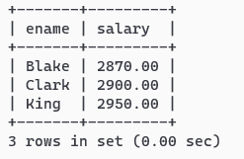

/*Question 6

Query to display Employee Name & Department Number for the Employee No= 790

*/

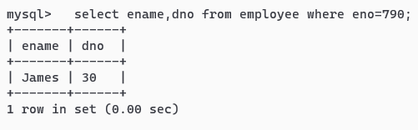

**/*Question 7**

**Query to display Employee Name & Salary for all employees whose salary is not in**

**the range of $1500 and $2850.**

**\*/**

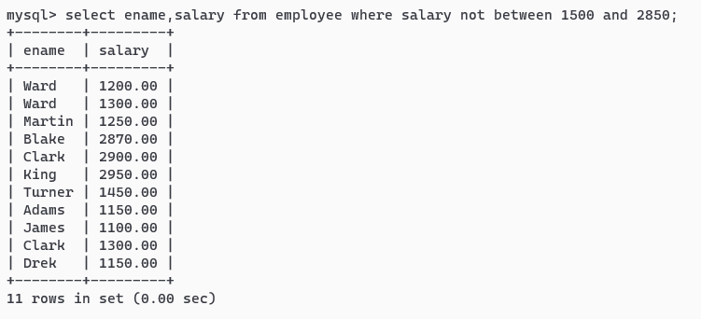

**/*Question 8**

**Query to display Employee Name, Job, and Hire Date of all the employees hired between Feb 20,**

**1981 and May 1, 1981. Order the query in ascending order of Start Date.**

**\*/**

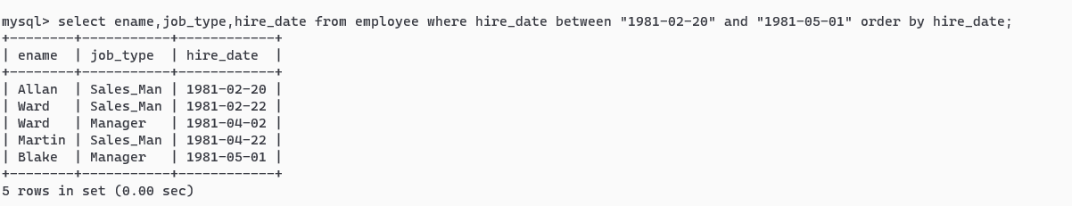

**/* Question 9**

**Query to display Employee Name & Department No. of all the employees in Dept 10 and Dept 30 in**

**the alphabetical order by name.**

**\*/**

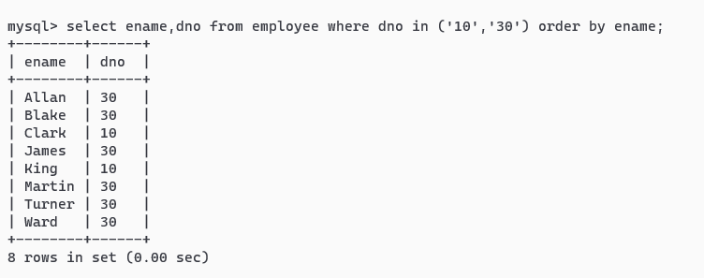

**/* Question 10**

**Query to display Employee Name & Salary of employees who earned more than $1500 and are in**

**Department 10 or 30.**

**\*/**

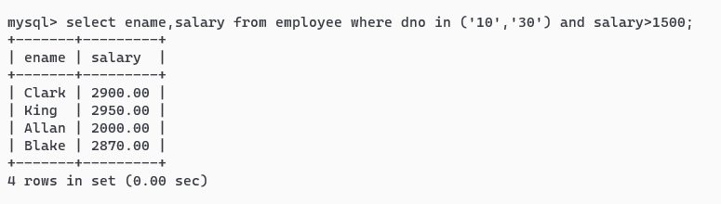

**/* Question 11**

**Query to display Name & Hire Date of every Employee who was hired after 1981.**

**\*/**

select ename,hire_date from employee where year(hire_date)>1981;

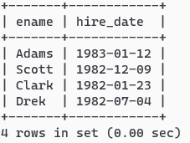

**/* Question 12**

**Query to display Name & Job of all employees who don’t have a current Manager.**

**\*/**

select * from employee where Manager is NULL;

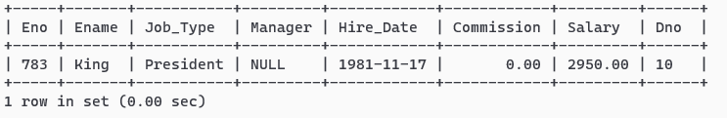

**/* Question 13**

**Query to display the Name, Salary & Commission for all the employees who earn commission. Sort**

**the data in descending order of Salary and Commission.**

**\*/**

select ename,salary,commission from employee where commission!=0 order by salary desc,commission desc;

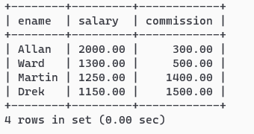

/* Question 14

Query to display Name of all the employees where the third letter of their name is ‘A’ and job type is

manager.

*/

select ename from employee where ename like "__A%" and job_type="Manager";

/* Question 15

Query to display Name of all employees either have two ‘R’s or have two ‘A’s in their name & are

either in Dept No = 30 or their Manger’s Employee No = 778.

*/

select ename from employee where ename like "%a%a%" or ename like "%r%r%" and dno="30" and Manager=778;

/* Question 16

Query to display Name, Job and Salary of all employees whose Job is Clerical or Analyst & their

salaries are not equal to 1000, 3000, or 5000.

*/

select ename,job_type,salary from employee where job_type="Clerical" or job_type="Analyst" and salary not in (1000,3000,5000);

/* Question 17

Query to display Name, Salary and Commission for all employees whose Commission Amount is

greater than their Salary increased by 5 %

*/

select ename,salary,commission from employee where commission>(1.05)*salary;

/* Question 18

Query to display the Current Date and the last date on which any employee joined.

*/

select curdate , max(hire_Date) from employee;

/* Question 19

Query to display Employee No., Name, Salary and the Salary increased by 15 % expressed as a

absolute whole number.

*/

select eno,ename,salary , FORMAT((salary*1.15),0) "115% SALARY" from employee;

/* QUESTION 20

Query to display Name, Hire Date and Salary Review Date which is the 1st Monday after six months of

employment.

*/

/*Question 21

Query to display the employees that earns a salary that is higher than the salary of any of the clerks

along with the difference in salary.

*/

/* Question 22

Query to display Name and calculate the number of months between today and the date each

employee was hired.

*/

select (year(curdate())-year(hire_date))*12+(month(curdate())-month(hire_date)) Month_Diff from employee;

/* Question 23

Query to display the following for each employee:- <E-Name> earns < Salary> monthly but wants < 3

* Current Salary >. Label the Column as Dream Salary

*/

select concat(ename," earns ",salary," monthly but wants ",3*salary) "Dream Salary" from employee;

/* Question 24

Query to display Name and Salary for all employees. Format the salary to be 15 character long, left

padded with $ sign.

*/

select lpad(salary,15,"$") from employee;

/* Question 25

Query to display Name with the 1st letter capitalized and all other letter lower case & length of their

name of all the employees whose name starts with ‘J’,’A’ and ‘M

*/

select concat(left(ename,1),substring(ename,2)) as Name from employee where ename like "J%" or ename like "A%" or ename like "M%" ;

/* Question 26

Query to display Name, Hire Date and Day of the week on which the employee started his/her job

*/

select ename , hire_date , dayofweek(hire_date) DayOfWeek from employee;

/* Question 27

Query to display Name and Commission Amount. If the employee does not earn commission then

use default value ‘No Commission’.

*/

select ename,if(commission>0,commission,"No Commission") from employee;

/* Question 28

Query to display Name, Department Name and Department No for all the employees.

*/

select ename , dname ,dno from employee natural join department;

/* Question 29

Query to display Unique Listing of all Jobs that are in Department # 30

*/

select distinct job_type from employee where dno="30";

/* Question 30

Query to display Name, Department Name and Location for all employees earning a commission

*/

select ename,dname,location from employee natural join department where commission>0;

/* Question 31

Query to display Name, Dept Name of all employees who have an ‘A’ in their name and works at

user-specified location.

*/

set @location=#EnterLoc;

"chicago";

select ename,dname from employee natural join department where (ename like "%A%") and location=@location;

/* Question 32

Query to display Name, Job, Department No. and Department Name for all the employees working

at the Dallas location.

*/

select ename,job_type,dno,dname from employee natural join department where location="Dallas";

/* Question 33

Query to display Name and Employee No. along with their Manager’s Name and Manager’s

employee no. */

select A.eno,A.ename,A.manager,B.ename "Manager's Name" from employee A , employee B where A.manager=B.eno;

/* Question 34

Query to display Name and Employee no. along with their Manger’s Name and the Manager’s

employee no; along with the Employees’ Name who do not have a Manager

*/

select A.eno,A.ename,A.manager,B.ename "Manager's Name" from employee A left join employee B on A.manager=B.eno or A.manager=NULL;

/* Question 35

Query to display the Employee No, Name and Salary for all employees who earn than the average

salary and who work in a Department with any employee with a ‘T’ in his/her name.

*/

select eno,ename,salary from employee where (salary >(select avg(salary) from employee)) and (dno =any(select dno from employee where ename like "%t%"));

/* Question 36

Query to display Name, Dept No. & Salary of any employee whose department No. and salary

matches both the department no. and the salary of any employee who earns a commission.

*/

select A.ename,A.dno,A.salary from employee A,employee B where B.dno=A.dno and A.salary=B.salary and B.commission>0 and A.commission=0;

/* Question 37

Query to display Name, Hire Date of any employee hired after the employee Blake was hired by the

Company

Assuming there is only one Blake

*/

select ename,hire_date from employee where hire_date>(select hire_date from employee where ename="Blake");

/* Question 38

Query to display Name and Hire Dates of all Employees along with their Manager’s Name and Hire

Date for all the employees who were hired before their managers

*/

select A.ename,A.hire_date,B.ename,B.hire_date from employee A, employee B where A.hire_date<B.hire_date and a.manager=b.eno;

/*Question 39

Query to display Name and Salaries represented by Asteristisks – “Each asterisks (*) signifying $100.

*/

select ename,repeat("*",salary/100) from employee;

/* Question 40

Query to display the Highest, Lowest, Sum and Average Salaries of all the employees

*/

select max(salary) Highest, min(salary) Lowest , sum(Salary) Sum , avg(salary) Average from employee;

/* Question 41

Query to display Highest, Lowest, Sum and Average Salary for each unique Job Type

*/

select job_type,max(salary) Highest, min(salary) Lowest , sum(Salary) Sum , avg(salary) Average from employee group by job_type;

/* Question 42

Query to display the number of employees performing the same Job type functions

*/

select count(*),job_type from employee group by job_type;

/* Question 43

Query to display the no. of managers without listing their names.

*/

select count(distinct manager) from employee;

/* Question 44

Query to display the Difference between the Highest and Lowest Salaries for each department

*/

select max(salary)-min(salary) from employee group by dno;

/* Question 45

Query to display the Manager’s No. & the Salary of the Lowest paid employee for that respective

manager. Exclude anyone where the Manager ID is not known. Exclude any groups where the minimum

salary is less than $1000.

*/

select manager,min(salary) from employee group by manager having manager is not null and min(salary)>1000;

/* Question 46

Query to display the Department Name, Location Name, No. of Employees & the average salary for

all employees in that department.

*/

select D.dno,location,count(eno),avg(salary) from employee E , department D where E.dno=D.dno group by D.dno;

/* Question 47

Query to display Name and Hire Date for all employees who work in the same dept. as Blake.

*/

select ename, hire_date from employee where dno=(select dno from employee where ename="Blake");

/* Question 48

Query to display the Employee No. & Name for all employees who earn more than the average

salary in their respective department

*/

select A.eno,A.ename,A.salary,B.salary from employee A, (select avg(salary) Salary,dno from employee group by dno ) B where A.salary>B.salary and a.dno=b.dno;

/* Question 49

Query to display Employee Number & Name for all employees who work in a department with any

employee whose name contains a ‘T’.

*/

select eno,ename from employee where dno in (select dno from employee where ename like "%t%");

/* Question 50

Query to display the employee name and salary of all employees who report to King.

*/

select ename , salary from employee where manager=(select eno from employee where ename="King");

/* Question 51

Query to display the Department No, Name & Job for top-5 employees (as per salary earned) in the

Sales Dept on descending order on name

*/

select dno ,ename,job_type,salary from employee where dno=(select dno from department where dname="Sales") order by salary desc LIMIT 5;

/* Question 52

Select manager name getting salary greater than average salary of employees in his department.

*/

select distinct b.ename , b.salary , c.salary Avg_Salary from employee A , employee B, (select avg(salary) salary,dno from employee group by dno ) C where a.manager=b.eno and b.dno=c.dno and b.salary>c.salary ;

/* Question 53

Create a view to store following information:

Dname| Location |Average salary| Number of Employee|Date of joining of first employee

*/

create view Demp as

select Dname,Location,b.salary Average_Salary, b.count "Number of Employee",b.hire_date "Date of joining of first employee"

from (select avg(salary) salary,dno,min(hire_date) hire_date,count(*) count from employee group by dno) B,

Department D where b.dno=d.dno ;